**BIRLA INSTITUTE OF TECHNOLOGY AND SCIENCE, PILANI**

Batch No. :

**DEPARTMENT OF COMPUTER SCIENCE AND INFORMATION SYSTEMS**

**Artificial Intelligence (BITS F444/ CS F407)**

**I Semester 2018-19**

**Programming Assignment-2**

**Coding Details**

**(September 27, 2018)**

*Instruction: Type the details precisely and neatly*

1. ID _________________2017H1030130P____________________________________________

Name ______________________Santosh Desai_______________________________________

1. Mention the names of Submitted files :
   1. Api.py
   2. Gui.py
   3. State.py
   4. Driver.py
   5. Helper.py
2. Total number of submitted files: ______5_____
3. Name of the folder :__________2017H1030130P_______________
4. Have you checked that all the files you are submitting have your name in the top?(yes/no)yes
5. Have you checked that all the files you are submitting are in the folder as specified in 4 (and no subfolder exists)?(yes/no)yes
6. Problem formulation
   1. State representation:

Array of stacks

* 1. How is the Initial state generated?

genInitState() takes 2 args : Number of blocks and number of stacks and generates randomly

* 1. What is the goal state?

Initial state is taken and shuffled with top blocks 10 times.

* 1. Are there more than one goal states?

No

* 1. If yes, then describe all the goal states. You can also describe a general method you used to create the goal state.
  2. State representation in Python (name the construct and give one small example of a state)

Class State in State.py is the representation. The given initial state is represented as

((19,120,26,16,90),(116,148,132),(104,31,28,37,200,81),(118,106,99,1,40,63,190,205,10),(14,32,20,36,78,22),(11,16,8,12,98,33,135,144,3),(39,70,86,55,100),(316,178,122),(141,302),(341,112,89,67,54,44))

Where each inner tuple is a stack.

1. Successor function description

A state is modified by transferring top block from source to destination stacks.

1. Informed Search Technique (T1) details
   1. Technique used for search:

Hill Climbing

* 1. Reason for selecting this technique over the other two:

Faster results than Greedy

* 1. Is the search applied on blocks (containers) or on states? States
  2. Error handling and reporting (yes/No): YES
  3. List the errors handled:

GUI related errors, division exceptions and using hash to check if all are processed.

* 1. Data Structure description for the tree node (in maximum two lines):

It contains

State : Array of stacks

Action : Source , destination pair

Cost: in units

Depth: recursive depth

Key: For heap

* 1. Code status (implemented fully/ partially/ not done)

Implemented fully

1. Informed search Technique (T2) details:
   1. Technique used for search: A*
   2. Reason for selecting this technique over others: Accuracy
   3. Does this technique look at a block? No
   4. Does this technique use a state? Yes
   5. Code status (implemented fully/ partially/ not done) Fully Implemented
   6. Define the heuristics (in words) used in your program
      1. h1 : greater Reward than Penalty
      2. h2 : Positional Reward and Static Penalty
   7. Compute (manually) the heuristic values for the following three states state 1, 2 and goal state as given in the following three figures 1,2 and 3 respectively. Write the values below appropriately.

State1 : h1 = 165 , h2 = 500

State2 : h1 = 179 , h2 = 502

Goal state : h1 = 270 , h2 = 978

104

31

28

37

200

81

11

16

8

12

98

33

341

112

89

67

54

44

3

144

135

141

302

316

178

122

39

70

86

55

100

14

32

20

36

78

22

118

106

99

1

40

63

10

205

190

132

148

116

16

90

26

120

19

p1

p2

p3

p4

p5

p6

p7

p8

p9

p10

Figure 1: state 1

104

31

28

37

200

81

11

16

8

12

98

33

341

112

89

67

54

44

3

144

135

141

302

316

178

122

39

70

86

55

100

14

32

20

36

78

22

118

106

99

1

40

63

10

205

190

132

148

116

16

90

26

120

19

p1

p2

p3

p4

p5

p6

p7

p8

p9

p10

Figure 2: State 2

104

31

28

37

200

81

11

16

8

12

98

33

341

112

89

67

54

44

3

144

135

141

302

316

178

122

39

70

86

55

100

14

32

20

36

78

22

118

106

99

1

40

63

10

205

190

132

148

116

16

90

26

120

19

p1

p2

p3

p4

p5

p6

p7

p8

p9

p10

Figure 3: Goal State

1. GUI details
   1. Created the GUI (yes/ No): Yes
   2. Have created it according to the specifications?(yes/No) Yes
   3. Which module of Python used for creating graphics? Tkinter
   4. Is this under the standard Python library or not? Yes
   5. If not, why?
   6. Are the window panes working independently? Yes
2. Graphics details:
   1. Is turtle/tkinter graphics working fine for movement of the blocks from one stack to another? YEs
   2. How are you creating the blocks? Block class and create_rectangle from tkinter
   3. How are you showing the stacks and movement of blocks?
      1. Orange Stacks on purple podium
   4. How are you showing the path of movement of blocks?

Selection(red), movement(green),consolidation(orange)

* 1. Are you showing the movement of the blocks as the execution of T1 goes on? Why? Yes
  2. Are you showing the movement of the blocks as the execution of T2 goes on? Why? Yes

1. Compilation Details:
   1. Code Compiles (Yes/ No):____Yes__________
   2. Mention the .py files that do not compile:_________N/A__________________________________
   3. Any specific function that does not compile:___________N/A____________________________
   4. Ensured the compatibility of your code with the specified Python version(yes/no)_____Yes_______
   5. Instructions for compilation of your files mentioning the multi file compilation process used by you (We may use the replica of these for compiling your files while evaluating your code)

Run Driver.py

1. Driver Details: Does it take care of the options specified earlier(yes/no):___Yes________
2. Execution status (describe in maximum 2 lines)

Excutes normally

1. Output Details
   1. Copy and paste the output of four graphs G1-G3 here

G1 , G2 and G3 (expand at convenience):

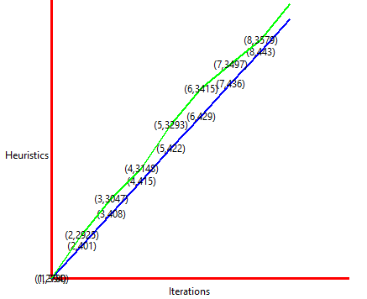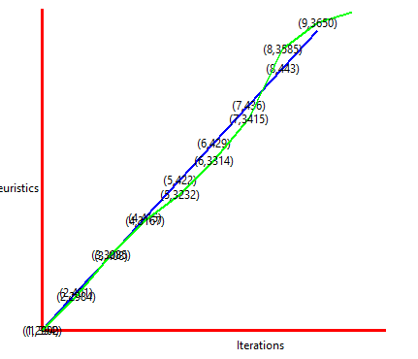

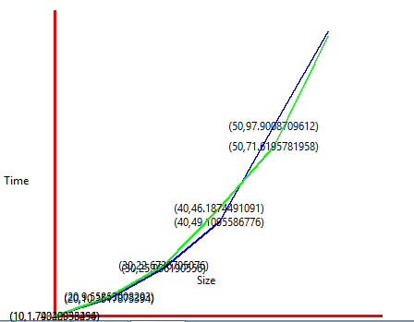

* 1. Write the following values computed by you (refer the details of R1-R12 in the assignment document). Use appropriate units for the values

Init = genInit(90,10) and goal = genGoal(init,10) produces:

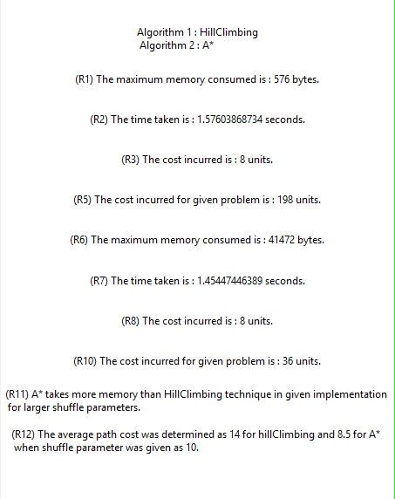

1. Any other detail: Run api.py once to get a list of two lists. The first list corresponds to hill Climbing algorithm while the second corresponds to A*. Paste them in line 131 and 132 against the hill and ast (declared as empty lists in submitted code) and uncomment the lines 134 and 135. Then and substitute green color for blue in line 135 and the code will accurately present G3.

For reference, one of the runs gives the following values :

Hill = [(10, 1.7434205349445075), (20, 10.351787339372954), (30, 25.906190556019318), (40, 49.109558677623745), (50, 97.90087096123055), (60, 145.99676393811666)]

Ast = [(10, 1.7902093625552529), (20, 9.558530082930767), (30, 22.67367050757462), (40, 46.18744910911007), (50, 71.61957819577682), (60, 117.19465637102621)]

1. Declaration: I, ___________________Santosh Desai_________ (name) declare that I have put my genuine efforts in creating the python code for the given programming assignment and have submitted only the code developed by me. I have not copied any piece of code from any source. If the code is found plagiarized in any form or degree, I understand that a disciplinary action as per the institute rules will be taken against me and I will accept the penalty as decided by the department of Computer Science and Information Systems, BITS, Pilani.

ID_____________2017H1030130P_________________

Name:_____________Santosh Desai_____________

Date: ______27-09-2018________

******************************************************************************* Should not exceed six pages